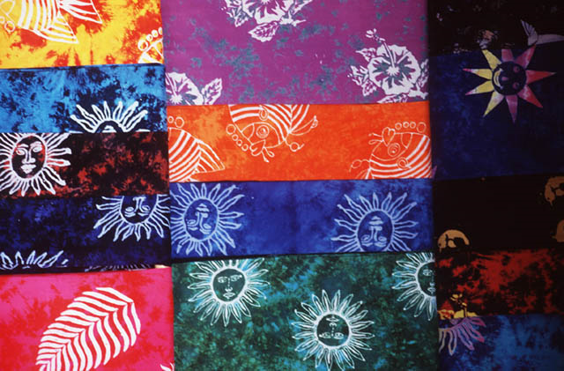
Custom Quilters, LLC

2018 Mill Creek Drive Arlington, TX 76010

682-241-1349 info@customquilters.com

www.customquilters.com

Interactive Form – Tab to each field to complete
Reserve your Appointment ~ Save and email to: info@customquilters.com

Print a copy and include with your quilt
How did you hear about us?
 |  |  |  |  |  |  |  | Order Request Information |  |  |  |  |  |  |  |  |  |  |  |  |  |  |  |  |  |  |  |  |  |  |  | CQ#
First Name |  |  |  |  |  |  |  |  |  |  |  |  |  |  |  |  | Last Name
Address
City |  |  |  |  |  |  |  |  |  |  |  |  |  |  |  |  |  |  |  |  |  |  |  |  | ST/PRO |  |  |  |  |  |  |  | Zip
Phone |  |  |  |  |  |  |  |  |  |  |  |  |  |  |  |  | Cell
Email |  |  |  |  |  |  |  |  |  |  |  |  |  |  |  |  | @
Preferred Contact |  |  |  |  |  |  | Time Morning Afternoon |  |  |  |  |  |  |  |  |  |  |  |  |  |  |  |  |  | Phone Cell Text Email
Are you a guild member? |  |  |  |  |  |  | Guild:
 |  |  |  |  |  |  |  |  |  |  |  |  |  |  |  |  |  |  |  |  |  |  |  |  |  |  |  |  |  |  | Square Inches |  |  |  |  |  |  |  | Perimeter Inches
 |  |  |  |  |  |  |  |  | Quilt Information |  |  |  |  |  |  |  |  |  |  |  |  |  |  |  |  |  |  |  |  |  | 0 |  |  |  |  |  |  |  | 0
Please identify the top of your quilt |  |  |  |  |  |  |  |  |  |  |  |  |  |  |  | Special Date Needed by?
Quilt Width – whole inches |  |  |  |  |  |  |  |  |  |  |  |  |  |  |  | Quilt Length - whole inches
Quilt Name/Description:
If you are providing your own backing / batting, it needs to be
EIGHT inches wider and longer to accommodate loading it onto the machine.
Batting |  |  |  | Provided by Customer |  |  |  |  |  |  |  |  |  |  |  |  |  |  | Type:
 |  |  |  | Purchase from Custom Quilters, LLC |  |  |  |  |  |  |  |  |  |  |  |  |  |  | Type:
Backing |  |  |  | Provided by Customer and backing is already pieced/squared
 |  |  |  | Materials provided by Customer and have it pieced by Custom Quilters, LLC. See Backing page.
 |  |  |  | Purchase wide backing material. |  |  |  |  |  |  |  |  |  |  |  |  |  |  | Fabric:
Bias Binding |  |  |  | Attach machine Front Only |  |  |  |  |  |  |  |  |  | Machine Finish |  |  |  |  |  |  |  |  |  |  |  |  |  | Machine Front & Hand finish back
 |  |  |  | Materials provided by Customer |  |  |  |  |  |  |  |  |  |  |  | Material sizes – see Binding page or contact us.
 |  |  |  | Purchase binding material |  |  |  |  |  |  |  |  |  |  |  | Fabric:
Trimming |  |  |  | Trim Quilt – do not bind |  |  |  |  |  |  |  |  |  |  |  | Do not trim Quilt & do not bind
Thread |  |  |  | Color |  |  |  |  |  |  |  |  |  |  | Color |  |  |  |  |  |  |  |  |  |  |  |  |  |  | Color
 |  |  |  | Item# |  |  |  |  |  |  |  |  |  |  | Item# |  |  |  |  |  |  |  |  |  |  |  |  |  |  | Item#
 |  |  |  | Brand |  |  |  |  |  |  |  |  |  |  | Brand |  |  |  |  |  |  |  |  |  |  |  |  |  |  | Brand
 |  |  |  | T/B |  |  |  |  |  |  |  |  |  |  | T/B |  |  |  |  |  |  |  |  |  |  |  |  |  |  | T/B
Top and bottom threads will be similar unless otherwise requested. If contrasting colors are used a small dots of thread will show.
Embroidery |  |  |  | Size |  |  |  |  |  |  |  |  |  |  | Font |  |  |  |  |  |  |  |  |  |  |  |  |  |  |  | Color
Label |  |  |  | # Rows |  |  |  |  |  |  |  | Fabric
 |  |  |  | Text
 |  |  | Quilting Desired

Basting for hand quilting
Design Name |  |  |  |  |  |  |  |  |  |  |  |  |  |  |  |  |  | Panto Group Border Block Custom
Design Name |  |  |  |  |  |  |  |  |  |  |  |  |  |  |  |  |  | Panto Group Border Block Custom
Design Name |  |  |  |  |  |  |  |  |  |  |  |  |  |  |  |  |  | Panto Group Border Block Custom
Note: Pantos run edge to edge across the quilt.
We place the long edge, up to 120 inches, of the quilt at the top of the machine. The backing seams need to run the same direction as the Pantos.
If you prefer to have the Panto quilted across the shorter edge of the quilt, there may be additional service fees.
Please mark the top of your quilt.
Special Order Request for Design / Pattern
Designer |  |  |  |  |  |  |  |  |  |  |  |  |  |  |  |  |  |  |  |  |  |  | Web Site
Design |  |  |  |  |  |  |  |  |  |  |  |  |  |  |  |  |  |  |  |  |  |  | Item Number
Questions – give us a call 682-241-1349
Special Instructions – send along anything that will help me with the quilting, pictures, and patterns. You can put additional text for labels, information anything.
Note:
If providing batting, it must be quality.
Inferior batting can contain trash, which could result in damage to your quilt.
Please see recommendations on batting web site page.
By emailing this completed form, I authorize Custom Quilters, LLC to complete the work listed above.
I understand that pictures are taken of the finished product for order verifications and may be used on Custom Quilter’s web site.
I understand that I am financially responsible for the cost of service rendered and for all materials used in the process.
If the quilt is displayed in a show or publication, Custom Quilters, LLC requests notification so that we can feature you on our web site. Let us know if you placed. Please credit the machine quilting to Custom Quilters, LLC.

Preferred Shipping: FedEx UPS other method USPS Parcel Post USPS Priority Mail
Insurance amount |  |  |  |  |  |  |  |  |  |  | $
If paying by charge card, do not send card information.
Custom Quilters, LLC will e-mail you an itemized invoice with your total along with a secure link to PayPal where you can enter the information for payment. PayPal works with all major credit cards.
Your private information is never out of your hands and the payment is secure.
If paying by check, or money order, we appreciate including a down payment with the quilt. However, Custom Quilters, LLC will e-mail or mail you an itemized invoice and you can mail a personal check or money order. Once the personal check has cleared, the quilt is shipped back to you.
Remember: We return all materials, not used, with the finished quilt.

- Complete the order form for each quilt. Include any special instructions.
- Place quilt, backing material (if applicable), batting (if applicable) and order form in plastic bag and seal. If shipping more than one quilt, include order for each.
- Do not use the word “quilt” on the outside of the box where someone will see it and suspect what is inside. Please ship in a secure box that will accommodate the finished quilt.
- Insure your package for the replacement cost in case of loss or damage.

For safety address the box personally to me:
Mark Clark
2018 Mill Creek Drive
Arlington, TX 76010

Signed: |  |  |  |  |  |  |  |  |  |  |  |  |  |  |  |  |  |  |  |  |  |  |  |  |  |  |  |  |  |  |  |  |  |  | Date:

